Read the exam style question carefully, then fill in each section below.
Question:
A scientist carries out the electrolysis of two aqueous salt solutions.
- Complete the table below to show the product at each electrode.

Salt solution | Product at positive electrode | Product at negative electrode
Silver nitrate
Lithium chloride

(4)

(b) Some students investigated the electrolysis of silver nitrate solution using inert graphite electrodes.

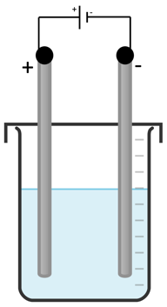
This diagram shows the apparatus:

Some of the silver produced did not stick to the negative electrode but fell to the bottom of the beaker.

Explain how the students could find the total mass of silver produced. (4)

Section 1: At first glance
1. What command words are used in this question? Circle them clearly.
2. Underline the key information in the question above.
2. How many marks is this question worth?

Section 2: Thinking ahead
Read the question again.
What do you need to know in order to answer this question really well?
Can you split the question into two or more parts?
Are there any labelled diagrams that might help you to show your answer?
What are the key words that you should include in your answer?

Section 4: Space to plan
Use this space to plan your answer.

Section 4: Answer the question
________________________________________________________________________________________________________________________________________________________________________________________________________________________________________________________________________________________________________________________________________________________________________________________________________________________________________________________________________________________________________________________________________________________________________________________________________________________________________________________________________________________________________________________________________________________________________________________________________________________________________________________________________________________________________________________________________________________________________________________________________________________________________________________________________________________________________________________________________________________________________________________________________________________________________________________________

Section 5: Check your answer
(a)
Salt solution | Product at positive electrode | Product at negative electrode
Silver nitrate | Oxygen (1) | Silver (1)
Lithium chloride | Chlorine gas (1) | Hydrogen (1)

(b)
- Filter the electrolyte/mixture (1)
- Wash the silver residue collected (1)
- Find the mass of the silver collected (1)
- Add this mass to the increase in the mass of the electrode/cathode (1)

